Digital Image Representation

Introduction
A digital image is a representation of a real-world scene in the form of numerical data that can be stored, processed, and displayed by a computer. It consists of a two-dimensional array (matrix) of pixels (picture elements), where each pixel stores one or more numerical values representing brightness or color.

Definition
Digital Image Representation is the method of storing an image as a collection of pixels, where each pixel contains intensity or color values that describe the visual content.

Types of Digital Image Representation
Digital images can be classified according to the number of bits used to represent each pixel.
Digital Images
│
┌───────────────┼────────────────┐
│ │ │
Binary Image(1bit) Grayscale(8bit)
Image Color Image
│
┌───────────┴─────────────┐
│ │
RGB Image CMYK Image
Abbreviation | Full Form | Used In | Description
RGB | Red, Green, Blue | Digital displays (monitors, TVs, smartphones, cameras) | An additive color model where different intensities of red, green, and blue light are combined to produce a wide range of colors.
CMYK | Cyan, Magenta, Yellow, Key (Black) | Printing (printers, magazines, newspapers, packaging) | A subtractive color model that uses cyan, magenta, yellow, and black inks to produce colors on white paper. The "K" stands for Key, which refers to the black printing plate used to add detail, contrast, and sharpness.

Applications of Different Image Representations
Image Type | Common Applications
Binary | OCR, QR codes, document scanning
Grayscale | Medical imaging, industrial inspection
RGB | Photography, multimedia, web graphics
CMYK | Printing and publishing
Indexed Color | Icons, GIF animations
Multispectral | Agriculture, remote sensing
Hyperspectral | Scientific research, mineral exploration

1. Binary Image (Black and White Image)

Definition
A binary image is the simplest type of digital image. Each pixel can have only two possible values:
- 0 = Black
- 1 = White
Each pixel requires only 1 bit.

Pixel Values
Pixel Value | Color
0 | Black
1 | White

Example Matrix
1 1 0 0
0 1 1 0
1 0 0 1
0 1 1 1

Characteristics
- 1 bit per pixel
- Small file size
- Simple processing
- No gray shades or colors

Applications
- Document scanning
- QR codes
- Barcodes
- Text recognition (OCR)
- Digital signatures

Advantages
- Very low storage requirements
- Fast processing
- Easy transmission

Disadvantages
- Cannot represent detailed photographs
- Limited visual information

2. Grayscale Image

Definition
A grayscale image contains different shades of gray instead of colors.
Each pixel stores an intensity value.

8-bit Grayscale
The most common grayscale representation uses 8 bits per pixel.
Number of gray levels:
2^8=256
Intensity range:
0→2550
Where:
- 0 = Black
- 255 = White
- Intermediate values = Shades of gray

Example Matrix
10 80 120
150 200 230
255 100 50

Characteristics
- 8 bits per pixel
- 256 gray levels
- Better detail than binary images

Applications
- X-ray images
- MRI scans
- Satellite imaging
- Industrial inspection
- Fingerprint recognition

Advantages
- Requires less storage than color images
- Preserves brightness information
- Suitable for image processing

Disadvantages
- Does not contain color information

3. Color Image

Definition
A color image represents each pixel using multiple color components.
The most common model is the RGB color model.

RGB Color Representation
Each pixel consists of:
- Red (R)
- Green (G)
- Blue (B)
Each channel is typically represented by 8 bits.
Therefore:
8+8+8=24 bits
Total colors:
2^24=16,777,2162
Approximately 16.7 million colors.

Example
A red pixel:
R = 255
G = 0
B = 0
A white pixel:
R = 255
G = 255
B = 255

Applications
- Digital photography
- Television
- Computer monitors
- Mobile phones
- Social media

Advantages
- Highly realistic
- Rich visual information
- Suitable for multimedia applications

Disadvantages
- Larger storage requirements
- Higher processing complexity

RGB Color Model
The RGB model is an additive color model used in displays.
Primary colors:
- Red
- Green
- Blue
Different combinations produce other colors.
R | G | B | Color
255 | 0 | 0 | Red
0 | 255 | 0 | Green
0 | 0 | 255 | Blue
255 | 255 | 0 | Yellow
0 | 255 | 255 | Cyan
255 | 0 | 255 | Magenta
255 | 255 | 255 | White
0 | 0 | 0 | Black

CMYK Image Representation

Definition
CMYK is a subtractive color model used mainly in printing.
Components:
- Cyan
- Magenta
- Yellow
- Key (Black)

Applications
- Newspapers
- Books
- Posters
- Packaging
- Professional printing

Difference Between RGB and CMYK
RGB | CMYK
Used for digital displays | Used for printers
Additive color mixing | Subtractive color mixing
Starts with black (no light) | Starts with white paper

Indexed Color Image

Definition
Instead of storing full color values for every pixel, an indexed image stores a color index that points to a color table (palette).

Characteristics
- Smaller file size
- Limited number of colors (often up to 256)

Applications
- GIF images
- Icons
- Simple graphics

Advantages
- Efficient storage
- Faster transmission

Disadvantages
- Limited color range

Multispectral and Hyperspectral Images

Multispectral Images
Capture several specific wavelength bands beyond visible light.
Applications:
- Agriculture
- Environmental monitoring
- Remote sensing

Hyperspectral Images
Capture hundreds of narrow wavelength bands.
Applications:
- Mineral exploration
- Precision agriculture
- Medical diagnostics
- Defense

Computer Image Processing Steps

Introduction
Computer Image Processing is the field of computer science that focuses on manipulating, analyzing, and interpreting digital images using mathematical algorithms and computational techniques. The primary objective is either to enhance the visual quality of an image for human viewing or to extract meaningful information for computer-based analysis.
Image processing plays a vital role in many modern applications, including medical imaging, satellite remote sensing, facial recognition, autonomous vehicles, industrial inspection, digital photography, robotics, and artificial intelligence.

General Image Processing Pipeline
Image Acquisition
↓
Image Preprocessing
↓
Image Enhancement
↓
Image Restoration
↓
Image Segmentation
↓
Feature Extraction
↓
Image Classification / Recognition
↓
Decision Making
Each stage performs a specific task that contributes to producing accurate and useful results.

Step 1: Image Acquisition

Definition
Image acquisition is the first step in image processing. It involves capturing an image using an imaging device and converting it into a digital format suitable for computer processing.

Sources of Image Acquisition
- Digital cameras
- Smartphone cameras
- Scanners
- CCTV cameras
- Medical imaging devices (MRI, CT, X-ray)
- Satellites and drones
- Microscopes

Process
- Capture the image.
- Convert the analog signal into digital data (if necessary).
- Store the image in memory.
- Prepare the image for processing.

Example
A security camera captures a person's face and stores it as a JPEG image for later analysis.

Step 2: Image Preprocessing

Definition
Image preprocessing improves the quality of the captured image before advanced analysis. The purpose is to remove unwanted distortions and prepare the image for further processing.

Common Preprocessing Operations

Noise Removal
Noise refers to unwanted random variations in pixel intensity.
Methods include:
- Mean Filter
- Median Filter
- Gaussian Filter

Contrast Adjustment
Improves visibility of image details.

Brightness Adjustment
Corrects images that are too dark or too bright.

Image Resizing
Changes image dimensions while preserving important information.

Color Space Conversion
Examples:
- RGB → Grayscale
- RGB → HSV
- RGB → YCbCr

Example
Before recognizing handwritten digits, background noise is removed using a median filter.

Step 3: Image Enhancement

Definition
Image enhancement improves the visual appearance of an image without changing its original content.
The objective is to make the image easier for humans or computers to interpret.

Enhancement Techniques

Histogram Equalization
Improves contrast by redistributing pixel intensity values.

Contrast Stretching
Expands the range of intensity values.

Sharpening
Highlights edges and fine details.

Smoothing
Reduces unwanted variations while preserving important structures.

Example
Enhancing low-light surveillance footage to improve visibility.

Step 4: Image Restoration

Definition
Image restoration reconstructs an image that has been degraded by blur, noise, or distortion using mathematical models.
Unlike enhancement, restoration attempts to recover the original image objectively.

Causes of Image Degradation
- Motion blur
- Camera shake
- Sensor noise
- Atmospheric distortion
- Optical imperfections

Restoration Techniques
- Wiener Filtering
- Inverse Filtering
- Blind Deconvolution
- Regularization Methods

Example
Removing motion blur from a traffic camera image.

Step 5: Image Segmentation

Definition
Image segmentation divides an image into meaningful regions or objects.
Each region represents an object or part of an object.

Importance
Segmentation simplifies image analysis.

Segmentation Methods

Thresholding
Separates objects using intensity values.

Edge-Based Segmentation
Detects object boundaries.

Region-Based Segmentation
Groups neighboring pixels with similar properties.

Clustering
Uses algorithms such as K-Means to group pixels.

Deep Learning Segmentation
Uses Convolutional Neural Networks (CNNs) for highly accurate segmentation.

Example
Separating a tumor from healthy tissue in an MRI scan.

Step 6: Feature Extraction

Definition
Feature extraction identifies important characteristics of segmented objects.
Instead of processing every pixel, only relevant features are extracted.

Common Features

Shape Features
- Area
- Perimeter
- Circularity

Color Features
- Mean color
- Color histogram

Texture Features
- Smoothness
- Roughness
- Repeating patterns

Edge Features
- Corners
- Boundaries
- Gradients

Example
A fingerprint recognition system extracts ridge endings and bifurcations as features.

Step 7: Image Classification and Recognition

Definition
Classification assigns an image or object to a predefined category, while recognition identifies the specific object.
Modern systems frequently use machine learning and deep learning techniques.

Classification Algorithms
- Decision Trees
- Support Vector Machines (SVM)
- K-Nearest Neighbors (KNN)
- Random Forest
- Artificial Neural Networks (ANN)
- Convolutional Neural Networks (CNN)

Example
Classifying images as:
- Cat
- Dog
- Car
- Human
- Tree
Face recognition systems identify a particular individual rather than simply detecting a face.

Step 8: Decision Making

Definition
The final stage uses the recognition results to perform an action or generate useful information.

Examples
- Unlocking a smartphone after successful face recognition.
- Detecting cancer from a medical image.
- Identifying road signs for autonomous vehicles.
- Counting vehicles in intelligent traffic systems.
- Detecting defective products on a manufacturing line.

Image Synthesis, Analysis, and Transmission
Image Synthesis, Image Analysis, and Image Transmission are three fundamental concepts in Multimedia Computing, Computer Graphics, Image Processing, Computer Vision, and Digital Communication. They describe the lifecycle of digital images: creation, interpretation, and communication.

1. Image Synthesis

Definition
Image Synthesis is the process of creating or generating digital images using computers. Rather than capturing an image with a camera, the computer mathematically constructs the image from models, objects, lighting, textures, and algorithms.

Formal Definition
Image Synthesis is the computational process of generating realistic or artificial images from mathematical models, geometric data, or computer-generated scenes.

Objectives of Image Synthesis
- Create realistic images
- Generate 2D and 3D graphics
- Simulate real-world environments
- Visualize scientific data
- Develop animations and games
- Support Virtual Reality (VR) and Augmented Reality (AR)

Image Synthesis Process(stages)
Scene Description
│
▼
3D Object Modeling
│
▼
Lighting and Materials
│
▼
Camera/Viewpoint Setup
│
▼
Rendering
│
▼
Final Digital Image

Summary of the Image Synthesis Process
Step | Description | Example
1 | Scene Description | Define objects, environment, and camera
2 | Geometric Modeling | Build 2D/3D object shapes
3 | Material & Texture Assignment | Apply colors, textures, and surface properties
4 | Lighting Setup | Add ambient, point, directional, or spot lights
5 | Camera Configuration | Choose viewpoint and perspective
6 | Hidden Surface Removal | Remove invisible surfaces
7 | Rendering | Generate the final 2D image from the 3D scene

Steps in Image Synthesis

Step 1: Scene Modeling
Objects are created using geometric shapes.
The computer receives information about:
- Objects
- Background
- Camera
- Lighting
- Colors
- Materials
This information is called the scene description.

Example
A virtual park may contain:
- Trees
- Grass
- Roads
- Buildings
- Cars
- People
- Sky
The computer stores these as mathematical models rather than photographs.

Example
- Cube
- Sphere
- Human model
- Car model

Step 2: Geometric Modeling

Definition
Geometric modeling creates the shape and structure of all objects in the scene.
Objects are represented using mathematical geometry.

Common Geometric Primitives
- Point
- Line
- Circle
- Triangle
- Polygon
- Sphere
- Cube
- Cylinder

Types of Modeling

2D Modeling
Used for:
- Logos
- Drawings
- Maps

3D Modeling
Used for:
- Movies
- Video games
- Architecture
- Medical visualization

Example
A car model contains thousands of polygons that define its body, wheels, windows, and lights.

Step 3: Material and Texture Assignment

Definition
After creating object shapes, visual properties are assigned.

Material Assignment
Each object is assigned properties such as:
- Color
- Texture
- Reflectivity
- Transparency

Material Properties
- Color
- Reflectivity
- Transparency
- Roughness
- Shininess

Texture Mapping
A texture is a digital image applied to an object's surface.

Examples
Object | Texture
Wall | Brick texture
Tree | Bark texture
Road | Asphalt texture
Human | Skin texture

Benefits
Without textures:
- Objects look flat.
- Scenes appear unrealistic.
With textures:
- Images become more natural and detailed.

Step 4: Lighting
Lighting determines the appearance of objects.
Types of lighting:
- Ambient light
- Point light
- Directional light
- Spot light

Definition
- Lighting determines how objects are illuminated and how shadows are formed.

Types of Light Sources

1. Ambient Light
- Illuminates all objects equally.
- Example:
- General room lighting.

2. Point Light
- Light radiates in all directions from one position.
- Example:
- A light bulb.

3. Directional Light
- Light rays are parallel.
- Example:
- Sunlight.

4. Spot Light
- Light is projected in a cone.
- Example:
- A flashlight or stage spotlight.

Step 5: Camera/View Configuration

Definition
The virtual camera determines how the scene will be viewed.

Camera Parameters
- Position
- Viewing direction
- Field of view (FOV)
- Zoom
- Perspective

Example
Changing the camera position changes the appearance of the same scene.
Just as in real photography, camera placement affects composition.

Step 6: Hidden Surface Removal

Definition
Objects hidden behind others should not appear in the final image.
This process removes invisible surfaces.

Rendering

Definition
Rendering converts the 3D mathematical scene into a final 2D image.
It calculates:
- Colors
- Shadows
- Reflections
- Transparency
- Lighting effects
Rendering is often the most computationally intensive stage.

Common Algorithms
- Z-Buffer Algorithm
- Painter's Algorithm
- Binary Space Partitioning (BSP)

Example
If a building is behind another building:
The hidden building should not be visible.

Applications of Image Synthesis

Entertainment
- Animated movies
- Video games
- Visual effects (VFX)

Engineering
- CAD design
- Architecture
- Product design

Medicine
- Organ visualization
- Surgical simulation

Education
- Virtual laboratories
- Scientific simulations

Weather Forecasting
- Satellite visualization
- Climate models

Advantages
- Produces realistic visualizations
- Reduces physical prototyping costs
- Supports simulations
- Enables interactive graphics

Real-World Example: Creating a 3D Car Advertisement
Suppose a company wants to create a realistic image of a new car before it is manufactured.

Step 1: Scene Description
Design a road, sky, mountains, and the car.

Step 2: Geometric Modeling
Create a detailed 3D model of the car.

Step 3: Material Assignment
Assign:
- Metallic paint
- Glass windows
- Rubber tires
- Chrome parts

Step 4: Lighting
Add sunlight and environmental lighting.

Step 5: Camera Setup
Place the camera to capture the best angle.

Step 6: Hidden Surface Removal
Remove parts of the car hidden from the camera's view.

Step 7: Rendering
Generate a realistic image with reflections and shadows.

Step 8: Post-processing
Adjust colors, sharpen the image, and add visual effects.
The final output is a high-quality image suitable for advertising.

Applications of Image Synthesis
- Entertainment: Animated movies, visual effects, and video games.
- Architecture: Virtual building designs before construction.
- Engineering: Product design and Computer-Aided Design (CAD).
- Healthcare: Surgical simulations and anatomical models.
- Education: Interactive 3D learning materials.
- Scientific Visualization: Weather forecasting, astronomy, and molecular modeling.
- Virtual Reality (VR) and Augmented Reality (AR): Immersive digital experiences.

Advantages
- Creates highly realistic or artistic images.
- Reduces the need for physical prototypes.
- Enables safe simulation of complex scenarios.
- Supports interactive visualization and training.
- Saves time and cost in design and development.

2. Image Analysis

Definition
Image Analysis is the process of extracting meaningful information from digital images using computer algorithms.
It converts image data into useful information for decision-making.

Formal Definition
Image Analysis is the process of detecting, measuring, classifying, and interpreting objects or features within an image.

Objectives
- Recognize objects
- Detect patterns
- Measure objects
- Classify images
- Support automated decision-making

Image Analysis Pipeline
Image Acquisition
│
▼
Preprocessing
│
▼
Segmentation
│
▼
Feature Extraction
│
▼
Classification
│
▼
Decision Making

Step 1: Image Acquisition
Capture images using:
- Digital cameras
- Medical scanners
- Satellites
- Drones

Step 2: Image Preprocessing
Improves image quality.
Common operations:
- Noise removal
- Contrast enhancement
- Image sharpening
- Histogram equalization

Step 3: Image Segmentation
Separates objects from the background.
Methods include:
- Thresholding
- Edge detection
- Region growing
- Clustering

Step 4: Feature Extraction
Extracts useful properties such as:
- Shape
- Color
- Texture
- Edges
- Corners

Step 5: Classification
Machine learning or deep learning algorithms classify the image.
Examples:
- Cat vs. Dog
- Healthy vs. Diseased
- Vehicle detection

Applications

Medical Imaging
- Tumor detection
- X-ray analysis
- MRI interpretation

Security
- Face recognition
- Fingerprint identification

Agriculture
- Crop monitoring
- Disease detection

Industry
- Quality inspection
- Defect detection

Remote Sensing
- Forest monitoring
- Disaster assessment

Advantages
- Faster than manual inspection
- High accuracy
- Consistent results
- Supports AI systems

3. Image Transmission

Definition
Image Transmission is the process of sending digital images from one location to another through communication channels.

Objectives
- Efficient image sharing
- Reduce transmission time
- Maintain image quality
- Ensure secure communication

Image Transmission Process
Image Capture
│
▼
Compression
│
▼
Encoding
│
▼
Communication Channel
│
▼
Decoding
│
▼
Decompression
│
▼
Display

Summary of the Image Transmission Process
Step | Description
1 | Image Capture – Acquire the image using a camera or scanner
2 | Image Digitization – Convert the image into digital pixel values
3 | Image Compression – Reduce file size
4 | Image Encoding – Convert compressed data into a transmission-ready bit stream
5 | Transmission – Send the data through a wired or wireless channel
6 | Reception – Receive the transmitted data
7 | Decoding – Recover the encoded image data
8 | Decompression – Restore the image from its compressed form
9 | Reconstruction – Recreate the digital image
10 | Display – Present the image to the user

Step 1: Image Capture

Definition
The first step is to acquire the image using an imaging device.

Devices Used
- Digital camera
- Smartphone camera
- Webcam
- CCTV camera
- Satellite sensor
- Medical imaging devices
  - MRI
  - CT Scan
  - X-ray

Example
A smartphone user takes a photo of a flower.
The camera sensor converts incoming light into digital pixel values.

Step 2: Image Digitization

Definition
If the image originates from an analog source, it is converted into a digital image.
Digitization consists of:

Sampling
Sampling divides the continuous image into a grid of pixels.

Quantization
Each sampled pixel is assigned a numerical intensity value.

Step 3: Image Compression

Definition
Compression reduces the image file size before transmission.

Why Compression?
Without compression:
- Transmission is slower.
- More bandwidth is required.
- Storage requirements increase.

Types of Compression

A. Lossless Compression
Characteristics:
- No information is lost.
- Original image can be perfectly reconstructed.
Examples:
- PNG
- TIFF (lossless)
- GIF
Applications:
- Medical imaging
- Scientific research
- Engineering drawings

B. Lossy Compression
Characteristics:
- Removes some image information.
- Produces much smaller files.
Examples:
- JPEG
- WebP (lossy)
- HEIF/HEIC
Applications:
- Social media
- Digital photography
- Websites

Step 4: Image Encoding

Definition
The compressed image is converted into a stream of binary data suitable for transmission.

Encoding Techniques
- Source encoding (efficient representation of image data)
- Channel encoding (adds redundancy to detect or correct transmission errors)

Purpose
- Improve transmission efficiency.
- Enhance reliability over noisy communication channels.

Step 5: Transmission Channel

Definition
The encoded data is transmitted through a communication medium.

Types of Channels

Wired
- Optical Fiber
- Ethernet
- USB

Wireless
- Wi-Fi
- Bluetooth
- 4G/5G Mobile Networks
- Satellite

Example
Uploading a photo from a smartphone to cloud storage using Wi-Fi.

Step 6: Image Reception
The receiver obtains the transmitted binary data.
Examples:
- Smartphone
- Laptop
- Server
- Cloud storage
- Medical workstation
The receiver verifies whether the data has arrived correctly.

Step 7: Image Decoding
The receiver decodes the incoming bit stream.
Decoding reverses the encoding process and, when error-control coding is used, detects or corrects certain transmission errors.

Step 8: Image Decompression
The compressed image is restored.

If Lossless Compression Was Used
The reconstructed image is identical to the original.

If Lossy Compression Was Used
The reconstructed image is visually similar, but some details may have been discarded during compression.

Step 9: Image Reconstruction
The decoded pixel values are arranged to recreate the image.
Image reconstruction may include:
- Color correction
- Brightness adjustment
- Noise reduction

Step 10: Image Display
The final image is presented to the user.

Display Devices
- Smartphones
- Computer monitors
- Tablets
- Smart TVs
- Medical displays

Factors Affecting Image Transmission

1. Bandwidth
Higher bandwidth allows more data to be transmitted per second.
Example: A 100 Mbps connection can transfer images faster than a 10 Mbps connection.

2. Latency
Latency is the delay before data begins to arrive.
Lower latency is important for real-time applications such as video conferencing.

3. Packet Loss
Packet loss occurs when some transmitted data packets fail to reach the destination.
High packet loss can lead to corrupted images, missing information, or the need for retransmission.

4. Compression Ratio
Higher compression reduces file size but may reduce image quality if lossy compression is used.

5. Noise
Noise in communication channels can introduce errors into transmitted data.
Error detection and correction techniques help maintain data integrity.

6. Network Congestion
Heavy network traffic can reduce transmission speed and increase delays.

Components

Source
Image generation device:
- Camera
- Scanner
- Smartphone

Compression
Reduces file size.
Examples:
- JPEG
- PNG
- HEIF

Encoder
Converts image into binary data.

Communication Channel
Transmission media include:
- Optical fiber
- Wi-Fi
- Mobile networks
- Satellite

Decoder
Recovers the transmitted data.

Display Device
Examples:
- Computer monitor
- Smartphone
- Television

Factors Affecting Image Transmission

Bandwidth
Higher bandwidth allows faster image transmission.

Latency
The delay between sending and receiving data.

Packet Loss
Lost packets can reduce image quality or require retransmission.

Compression Ratio
Higher compression reduces file size but may lower image quality (lossy compression).

Mathematical Representation
Transmission time can be estimated as:
T=Image Size (bits)/Transmission Rate (bits/s)

Example
Image size = 10 MB
Transmission rate = 20 Mbps
Convert 10 MB to bits:
10×8=80 Mb
Transmission time:
T=80/20=4 seconds

Applications

Social Media
Image sharing

Telemedicine
Medical image transfer

Remote Learning
Sharing educational images

Satellite Imaging
Earth observation

Cloud Storage
Image backup and synchronization

Advantages
- Fast communication
- Global accessibility
- Supports real-time collaboration
- Enables remote diagnosis and monitoring

Comparison of Image Synthesis, Analysis, and Transmission
Feature | Image Synthesis | Image Analysis | Image Transmission
Purpose | Generate images | Extract information | Send images
Input | Mathematical models or scene descriptions | Captured digital images | Digital image data
Output | New digital image | Features, measurements, or classifications | Received image at the destination
Key Technologies | Computer graphics, rendering | Image processing, computer vision, AI | Compression, encoding, networking
Applications | Animation, gaming, CAD, VR | Medical diagnosis, surveillance, quality inspection | Telemedicine, social media, cloud storage

Real-World Example
Imagine a hospital using digital healthcare technologies:
- Image Synthesis: A 3D model of a patient's heart is generated from CT scan data to help surgeons plan an operation.
- Image Analysis: AI analyzes the CT images to detect blocked arteries and measure abnormalities.
- Image Transmission: The images and analysis results are compressed and securely transmitted over the internet to a specialist in another city for consultation.

Conclusion
Image Synthesis, Analysis, and Transmission are three interconnected pillars of multimedia computing.
- Image Synthesis focuses on creating digital images from mathematical models and virtual scenes.
- Image Analysis focuses on understanding and extracting meaningful information from images using image processing and AI techniques.
- Image Transmission focuses on efficiently and securely delivering images across communication networks.
Together, these technologies power applications in healthcare, education, entertainment, autonomous systems, remote sensing, scientific visualization, digital communication, and modern multimedia systems.

What is Image Recognition?
Image Recognition is a branch of Computer Vision and Artificial Intelligence (AI) that enables computers to identify, classify, and interpret objects, people, places, text, or activities in digital images.

Definition
Image Recognition is the process of acquiring a digital image, extracting meaningful features, and using algorithms or machine learning models to recognize and classify the objects or patterns present in the image.

Examples
- Face recognition for smartphone unlocking.
- Identifying plants from a photo.
- Detecting tumors in medical images.
- Reading vehicle license plates.
- Recognizing handwritten digits.

Image Recognition Process
Image Acquisition
│
▼
Image Preprocessing
│
▼
Image Segmentation
│
▼
Feature Extraction
│
▼
Feature Selection
│
▼
Model Training (Machine Learning/Deep Learning)
│
▼
Image Classification
│
▼
Recognition & Decision

Step 1: Image Acquisition

Purpose
Capture or obtain the image to be analyzed.

Sources
- Digital cameras
- Smartphones
- CCTV cameras
- Drones
- Satellites
- Medical scanners (MRI, CT, X-ray)

Example
A smartphone captures a picture of a flower for identification.

Fact
Modern smartphone cameras commonly capture images with resolutions of 12 MP, 48 MP, 50 MP, or higher, providing detailed visual information for recognition tasks.

Step 2: Image Preprocessing

Purpose
Improve image quality before analysis.

Common Techniques

Noise Removal
Removes unwanted disturbances.

Contrast Enhancement
Improves visibility.

Image Sharpening
Highlights edges and details.

Brightness Adjustment
Corrects lighting conditions.

Image Resizing
Resizes images to the input size expected by AI models.

Example
A blurred medical X-ray is enhanced before disease detection.

Fact
Good preprocessing can significantly improve the accuracy of image recognition systems because it reduces irrelevant variations in the input data.

Step 3: Image Segmentation

Purpose
Separate important objects from the background.

Common Methods
- Thresholding
- Edge Detection
- Region Growing
- Watershed Algorithm
- Clustering

Example
Separating a leaf from the background before identifying the plant species.

Step 4: Feature Extraction

Purpose
Extract useful characteristics that uniquely describe the object.

Common Features
- Color
- Shape
- Texture
- Edges
- Corners
- Size

Example
Face recognition systems analyze:
- Distance between the eyes
- Nose shape
- Jawline
- Facial contours

Step 5: Feature Selection

Purpose
Choose only the most informative features while removing unnecessary or redundant information.

Benefits
- Faster computation
- Lower memory usage
- Better model performance
- Reduced overfitting

Example
Instead of using thousands of image measurements, the algorithm selects only the most important ones.

Step 6: Model Training

Purpose
Train an AI model to recognize objects using labeled images.

Machine Learning Algorithms
- Support Vector Machine (SVM)
- Decision Tree
- Random Forest
- K-Nearest Neighbors (KNN)

Deep Learning Algorithms
- Convolutional Neural Networks (CNNs)
- Residual Networks (ResNet)
- Vision Transformers (ViTs)

Example
A CNN is trained using thousands of labeled images of cats and dogs.

Fact
Deep learning models generally require large, diverse datasets to achieve strong performance, but they have greatly improved image recognition accuracy across many applications.

Step 7: Image Classification

Purpose
Assign the image to one or more predefined categories.

Example
Input Image → Output Class
- Cat → "Cat"
- Dog → "Dog"
- Car → "Car"

Step 8: Recognition and Decision

Purpose
Provide the final recognition result or trigger an action.

Examples
- Unlock a smartphone after recognizing the owner's face.
- Detect cancer cells in medical images.
- Identify a defective product on a manufacturing line.
- Read vehicle number plates at a toll gate.

Example: Face Recognition
Capture Face
│
▼
Preprocessing
│
▼
Face Detection
│
▼
Feature Extraction
│
▼
Face Comparison
│
▼
Identity Verification

Real-World Applications

1. Healthcare
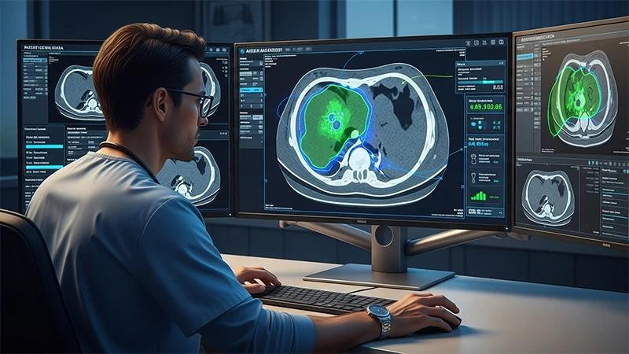
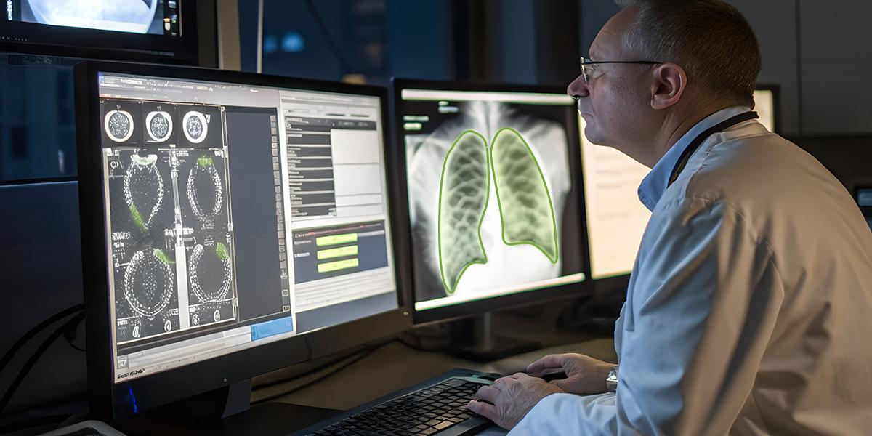
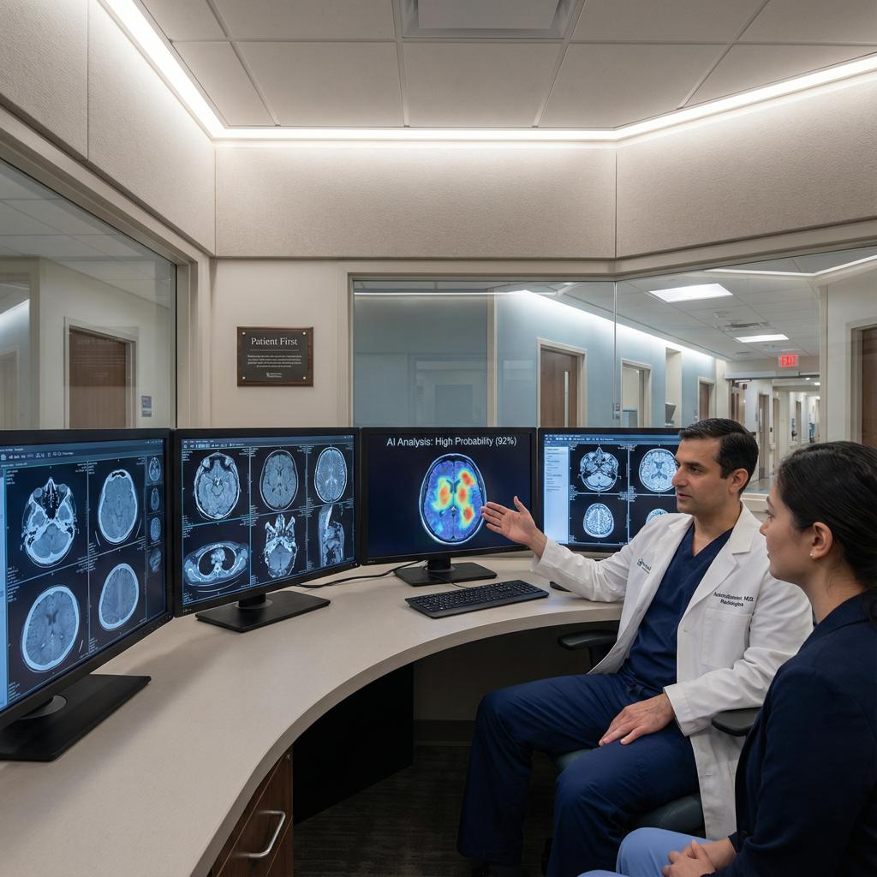
4
- Tumor detection
- X-ray analysis
- Disease diagnosis
- Medical image segmentation

2. Security
- Face recognition
- Fingerprint verification
- Surveillance systems
- Access control

3. Agriculture
- Plant disease detection
- Crop monitoring
- Weed identification
- Fruit quality assessment

4. Transportation
- Traffic sign recognition
- License plate recognition
- Driver assistance systems
- Autonomous vehicles

5. Retail
- Barcode scanning
- Product identification
- Automated checkout
- Inventory management

6. Education
- Handwriting recognition
- Digital document analysis
- Smart learning systems

Advantages
- Fast and automated recognition
- High accuracy with modern AI models
- Reduces manual effort
- Operates continuously without fatigue
- Supports real-time decision-making
- Improves productivity across industries

Challenges
- Performance can decrease with poor lighting or low-resolution images.
- Occluded or partially visible objects are harder to recognize.
- Similar-looking objects may be confused.
- Large labeled datasets are often required for training.
- Recognition systems must address privacy, fairness, and security concerns.

Summary
Step | Description
1 | Image Acquisition – Capture the image
2 | Image Preprocessing – Improve image quality
3 | Image Segmentation – Isolate the object of interest
4 | Feature Extraction – Compute distinctive characteristics
5 | Feature Selection – Retain the most useful features
6 | Model Training – Train an AI or machine learning model
7 | Image Classification – Predict the object's category
8 | Recognition & Decision – Produce the final result or action

Conclusion
Image Recognition combines image processing, computer vision, and artificial intelligence to enable computers to understand visual information. It follows a structured pipeline—from image acquisition and preprocessing to feature extraction, model training, classification, and final decision-making. 